Berthing vessels at Main Wharf

The Main Wharf project commenced in November 2019 and was completed in August 2021.
It involved the replacement of the northern 100m section of Main Wharf. This extends the operating section of main wharf from 180m to 280m. This upgrade enhances the Ports capability for berthing vessels up to 270m in length. It is not just beneficial to the business operations, by provides resilience to our business during natural disasters, but also provides positive effects on the Port noise mitigation.

Figure 1 below shows the previous berthing location of the “MSC Astrid” at a length of 231m, with the bow in line with the southern end of Main Wharf.
Figure 2 below shows the new location of the “MSC Astrid” following the replacement allows the vessel “MSC Astrid” to be berth 36m further North along Main Wharf.
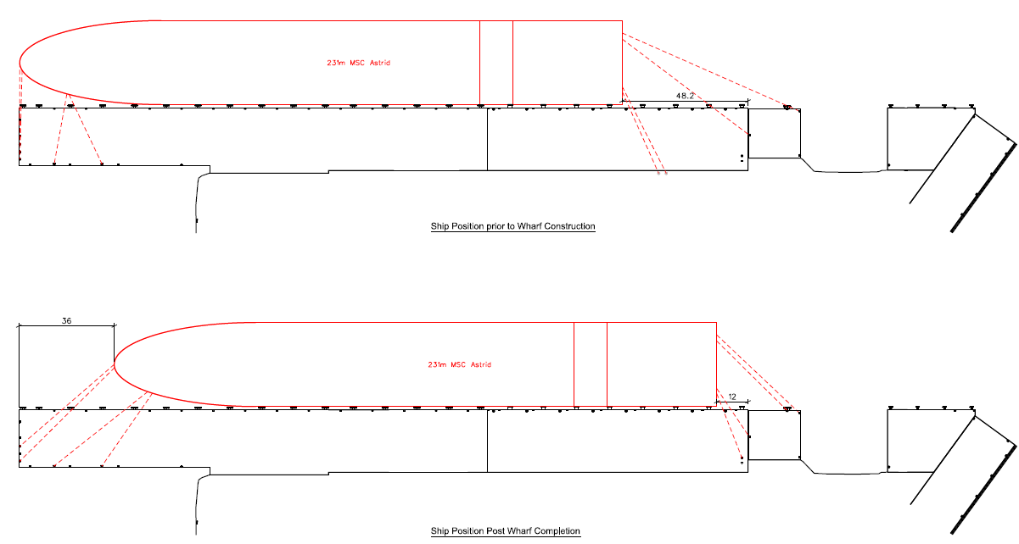
Figures 1 & 2. Shift of the Vessel Berth Location after the Main Wharf North Upgrade
The length of vessels berthed at Main Wharf range between 180m and 270m.
As shown in Figure 3 below, part of the vessel continues to berth at the southern end of Main Wharf, however the aft of the vessel is located further north on main wharf. The crane operation area, shown in Figure 3, is now on the central and northern end of the wharf, with crane operations no longer on the southern finger.

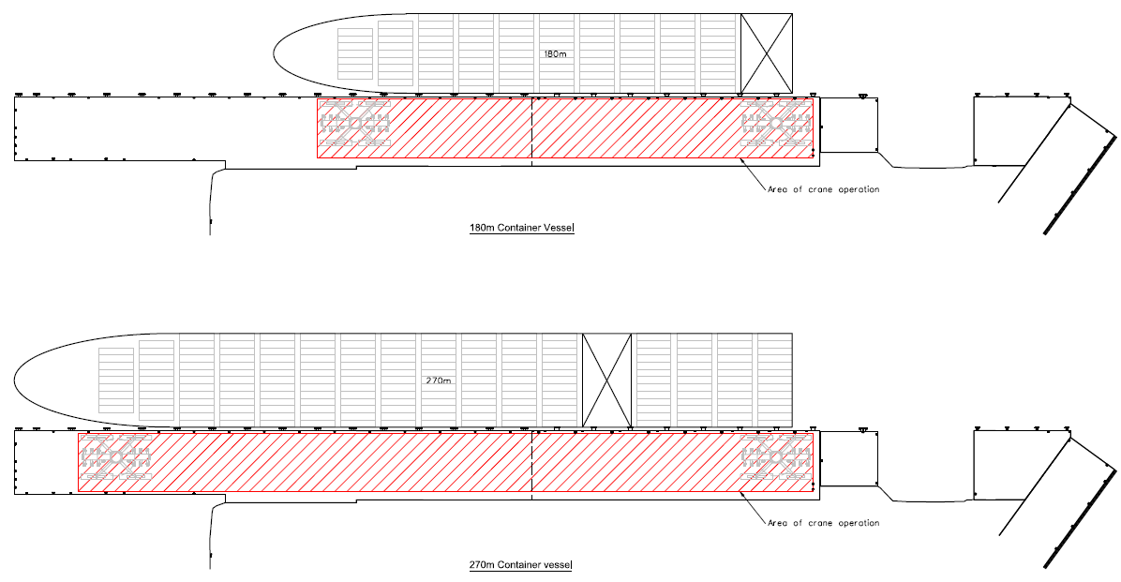
Figure 3. Crane Operation Area on Main Wharf

Port operation arrangements, safety concerns and vessel’s design means that not all vessels are able to be berthed at the Northern end of Main Wharf and Port Nelson endeavours to berth these vessels to minimise noise impacts to residents.

